IN OFFICE SURGICAL PROCEDURE- ADMINISTERED MEDICATIONS

NAME : ______________________________________DATE: _____________________

AGE: __________ DOB: __________________________SEX: ____________________
_______________________

SURGICAL PROCEDURES: ____________________________________________________________________________________________________________________________________________________

MEDICATIONS: __________________________________________________________________________
__________________________________________________________________________

DRUG ALLERGIES: ________________________________________________________

CONSENT SIGNED IN CHART: YES NO

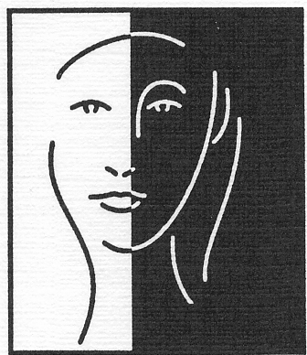
TIME | FENTANYL | MIDAZOLAM | PHENERGAN | ROCEPHIN | MARCAINE | LIDO W/EPI 1% | LIDO W/EPI 2% | IV FLUIDS

